**DETERMINATION OF AEROSOL OPTICAL PROPERTIES FOR RETRIEVAL OF WATER-LEAVING RADIANCE AT ROODEPLAAT DAM RELATING TO CALVAL OF SENTINEL 2 AND 3.**

**ABSTRACT**

The use of satellite imagery is gaining popularity in Earth Observation (EO). Then it is necessary to assess the quality of the collected data, with the launch of two satellites sentinel 2 and sentinel3. A number of vicarious calibrations have been practiced several times to evaluate Aerosol Optical Properties at roodeplaat dam in May 2016 in Pretoria.at Gauteng province. The results were compared to the Aeronet meter that is situated on top of the CSIR building in Pretoria. A number of radiometric calibration experiments have been performed in this dam within a month. The in situ- measurements were collected simultaneously with the sentinel 2 and sentinel 3 overpasses over selected dates and days.

**INTRUDUCTION**

Remote sensing data use in this country is increasing in a high rate. It provides knowledge about Earth operation system and it is more concentrating on weather conditions, climate changes, operation of the land and changes over it, natural resources, ecosystems, and human induced hazards **[1].** Now through the ESA who led to the commission of sentinel 2 and sentinel 3 satellites, Sentinel is a family of satellites developed by ESA specifically for the operational needs of Copernicus program. The European Space Agency (ESA) is planning to launch six sentinel satellites and the first three is out sentinel 1, 2 and 3. Sentinel two and three will be the two satellites that will be calibrated. Sentinel 2 is a polar orbiting multispectral high- resolution imaging mission for land monitoring. It mainly focuses on the vegetation imagery; soil and water cover inland water and coastal areas. It has two cycles the first orbit sentinel 2A was launched on the 23 June 2015 by ESA and sentinel 2B will follow on the second half of 2016**[2**]**.**. Since the satellite is launched in the stratosphere layer there are possibilities of contamination because of the chlorofluorocarbons that are being destroyed by the ozone. The atmosphere can have some effects such as degradation of the optical system and changes in the offset, spectral response of the other detectors and stability. The performance of radiometric calibration and validation of the imaging system is necessary in order to correct that **[1].** The main aim of performing radiometric calibration on this area is to determine an exact incident spectral radiance and its output from the instrument. They are various vicarious calibration types that were used in order to complete the test, (1) pre-launch calibration; (2) ground based vicarious calibration **[3].** For Sentinel Satellitevicarious calibration is preferred for determination of aerosol properties. Vicarious calibration is based on the on the measurements that are performed over a selected area on top of the Earth simultaneously with the satellite overpass.

A ground vicarious calibration was performed at Roodeplaat Dam from the 05, 06 and 24 of June 2016 by CSIR (Council for Scientific and Industrial Research) student and a researcher together with NRE (Natural Resources and the Environment) workers. The collected data is presented on this paper. The data include the atmospheric thickness (AOT) water vapour in the atmosphere, atmospheric pressure, latitude, longitude, temperature, and **sentinel overpass** over the area.

**RADIOMETRIC CALIBRATION SITE**

The radiometric vicarious calibration site during the satellite sentinel 2(A) overpass. Roodeplaat dam is huge dam surrounded by trees and some green plants. There human settlements around the dam, and some industries which are not far from the dam which may lead to the increase of aerosols hence they release lots of smoke.

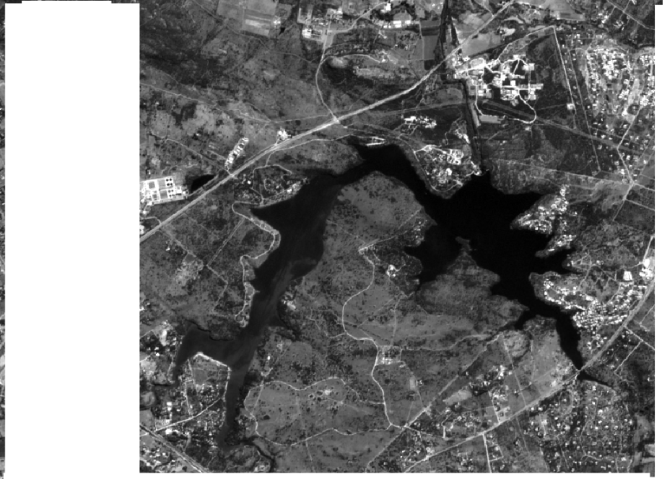 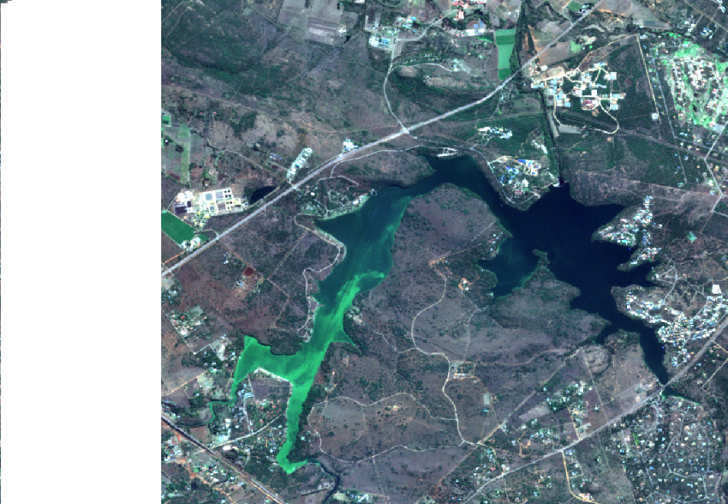

Figure1:

1. Roodeplaat Dam (b) Roodeplaat Dam red, green and blue combination

**INSTRUMENTATION AND METHODOLOGY**

Surface reflectance measurements were taken at Roodeplaat Dam on the 05, 06 and 24 June 2016. Micro tops sun photometer was used to measure some of the atmospheric parameters such as AOT which operates between440, 500, 675, 870 and 936. It is a good meter because it records detailed parameter. A model of 540 micro tops II sun photo meter is a five channel hand held meter for measuring aerosol optical thickness easily, accurately and dependably. The measurements were taken simultaneously with the satellite overpasses. The results from the sun photometer were then compared to the Aeronet results recorded from the top of the CSIR building.

**Analytical spectral devices (ASD)**

Using the ASD/BWTek instrument the computation and diffuse /global spectral irradiance ratio was calculated. The second instrument used for collecting data is the ASD field spectrum. It is a portable field spectrum instrument

ASD is the second instrument that was used for collecting the roodeplaat data. The ASD is one of the trusted instruments for collecting data as it because it is designed to collect solar reflectance, radiance and irradiance measurements. This instrument is most consistent for various applications including optical remote sensing. It is a dense and easy to setup instrument and it collects more data. It offers a superior signal-intensify features and a high resolution with a 350-2500 nm spectral range. It has a back pack mounted machine that enables it to the collection of spectral measurements wherever you want to go. It makes it easier to acquire field data in a faster rate [4].

**Spectral radiometer**

A spectroradiometer is an instrument that is designed to measure spectral radiance or irradiance across various spectral ranges. It is a small TE cooled spectral irradiance meter designed for industrial applications and lab use with a USB 2.0 border. It has a built in optical measuring and targeting system measuring light from different directions of scattering irradiance. It is a reliable machine hence it’s calibrated by NIST traceable Tungsten light source. Spectral radiometer has its own software BWSpec for characterising measurements. There are various applications that collect their measurements using this instrument including lighting devises and systems [5].

**RESULTS AND DISCUSSIONS**

**CONCLUSION**

**ACKNOWLEDGEMENT**

**REFERENCES**

1 .D.J. GRIFFITH, M HORLENT, G.IBAEZ, M.D LYSKO. M.LUBBE, A.E MUDAU, S.TORRUSIO, V.SIVAKUMAR AND L.M VHENGANI, AUGUST 2011vicarious calibration campaign in Argentina for radiometric calibration of a multispectral imager on board sumbandila satellite.

2 .European Space Agency family of satellites in commission with Copernicus program, April 2014.

3. Joe Tansock, Daniel Bancroft, Jim Butler, Changyong Cao, Raju Datla, Scott Hansen, Dennis Helder, Raghu Kacker, Harri Latvakoski, Martin Mlynczak, Tom Murdock, James

Peterson, David Pollock, Ray Russell, Deron Scott, John Seamons, Tom Stone, Alan Thurgood, Richard Williams, Xiaoxiong (Jack) Xiong, Howard Yoon, Guidelines for Radiometric Calibration of Electro-Optical instruments for Remote Sensing April 2015.

4 <http://www.asdi.com/products-and-services/fieldspec-spectroradiometers> 04/07/2016

5. http://bwtek.com/products/spectrarad/,05/07/2017